Lab-11 Constraints

Output

CREATE DEPARTMENT TABLE

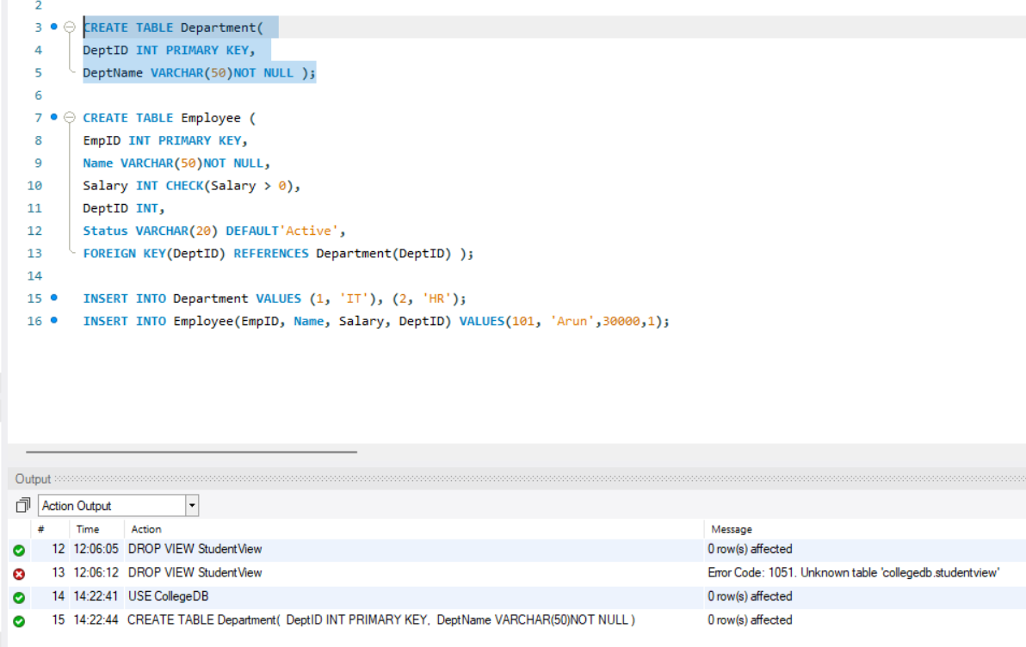

CREATE EMPLOYEE TABLE

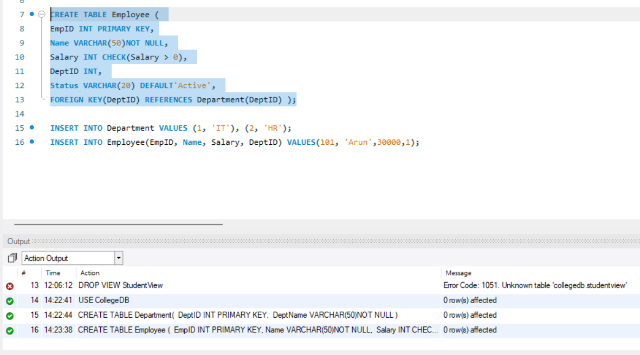

INSERT INTO DEPARTMENT

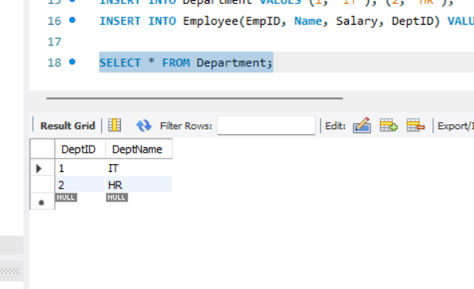

INSERT INTO EMPLOYEE

